# MY HEALTH TOOLS

The **My Health Tools** tab helps you find more information about your medical conditions, medications, and lab tests. To begin, click on any subject.

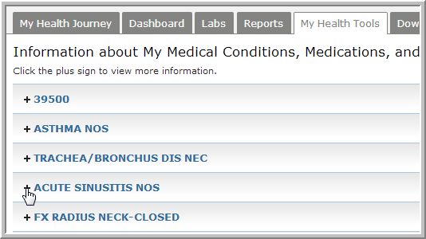

A concise summary of the problem along with links to further reading are included.

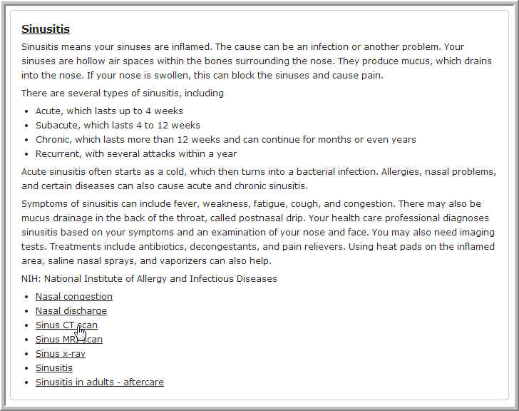

All links are to pages maintained by MedlinePlus (<http://www.nlm.nih.gov/medlineplus/>), a service of the U.S. National Library of Medicine and NIH (National Institutes of Health).

